27th aug 2024 AWS EFS

1] create EFS file system

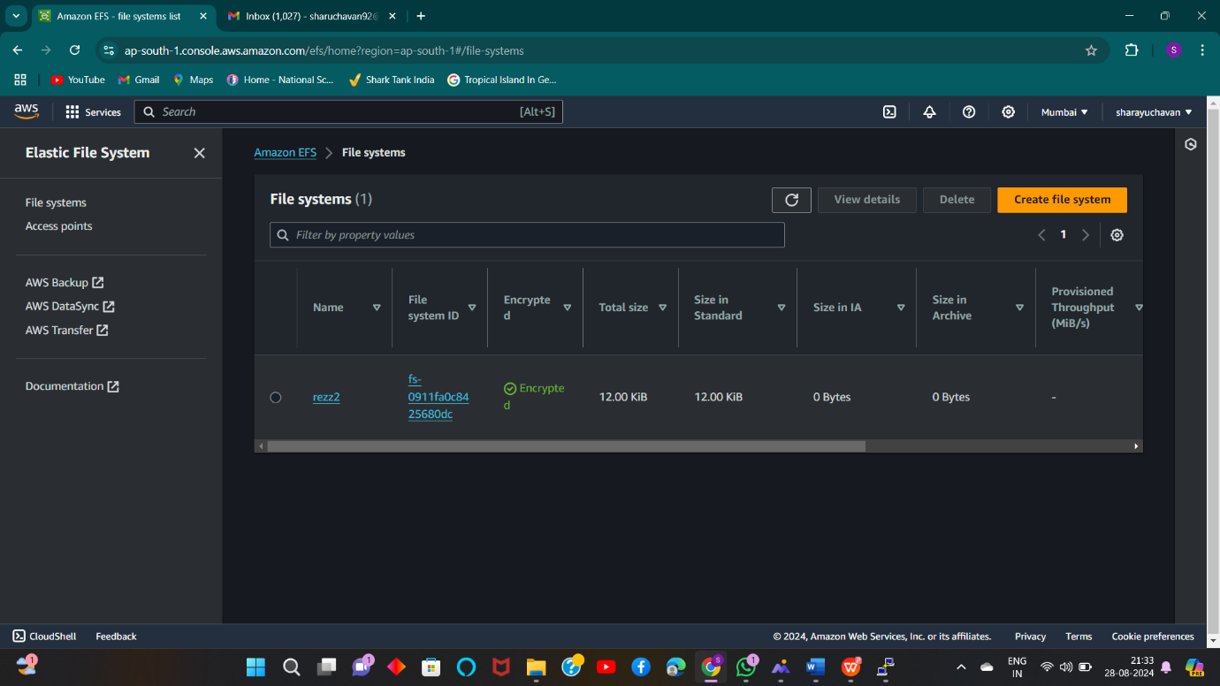

2] Create two instances in different zone added one security grp with 2049 (nfs)port

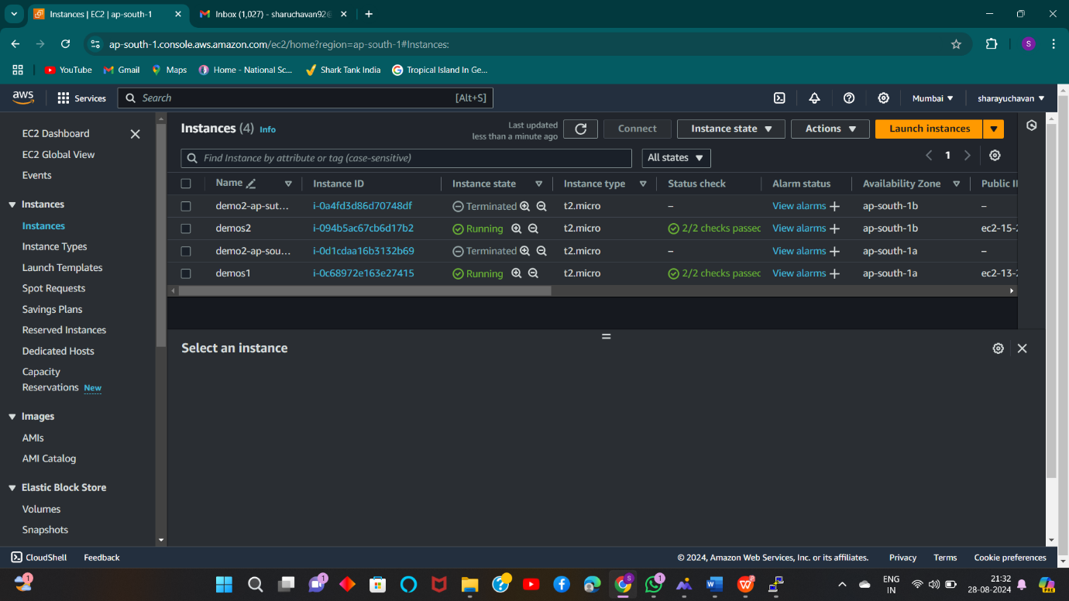

3] Mount Security Group on Created EFS files

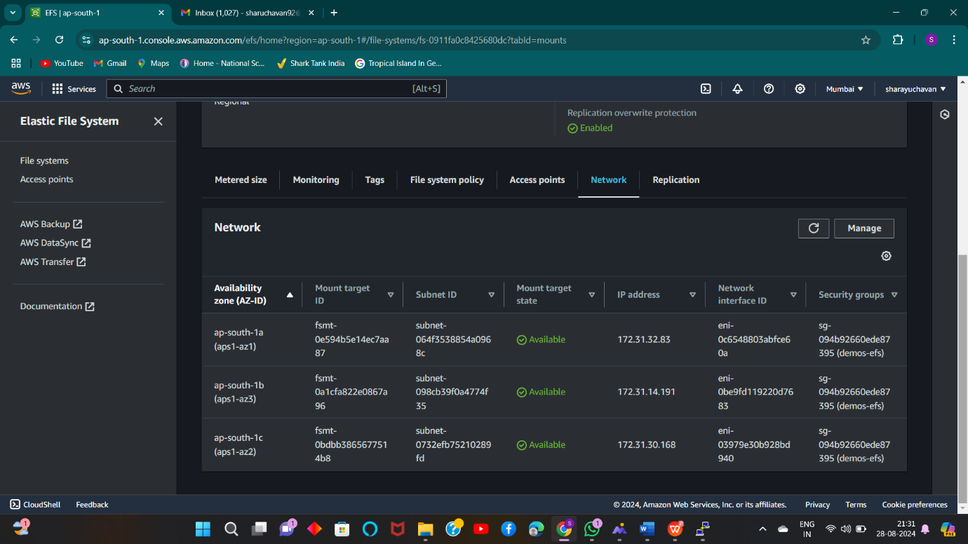

4] Mount EFS file system for both the EC2 instances

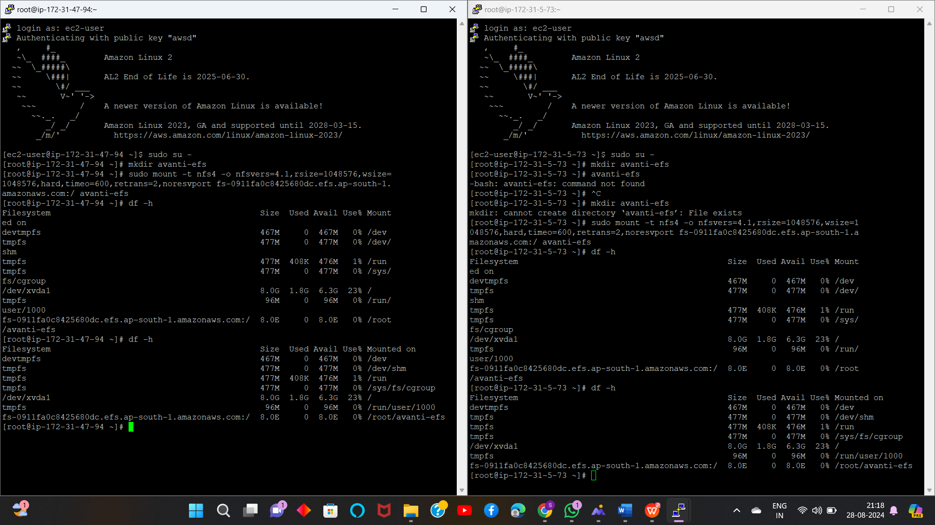

5] EFS have been successfully mounted on vm

